**Own-It**

Submitted in partial fulfillment of the requirements

of the syllabus of

Android Apps Development Lab

in

Information Technology

by

Akash Maurya 118A3026

Rajkumar Kolanji 118A3042

Under the Guidance of:

Ms. Bushra Shaikh



Department of Information Technology

SIES Graduate School of Technology

2021-22

**CERTIFICATE**

This is to certify that the project entitled **“**Own-It**”** is a bonafide work of the following students, submitted to the University of Mumbai in partial fulfillment of the requirement of the syllabus of **Android Apps Development Lab** in **Information Technology.**

**Akash Maurya 118A3026**

**Rajkumar Kolanji 118A3042**

Ms. Bushra Shaikh Dr. Lakshmi Sudha Dr. Atul N Kemkar

Internal Guide Head of Department Principal

**PROJECT REPORT APPROVAL**

This project report entitled ***Own-It*** by following students is approved for the requirement of the syllabus of ***Android Apps Development Lab*** in ***Information Technology.***

**Akash Maurya 118A3026**

**Rajkumar Kolanji 118A3042**

**Name of External Examiner: --------------------------------**

**Signature:--------------------------------**

**Name of Internal Examiner: --------------------------------**

**Signature:--------------------------------**

**Date:**

**Place:**

**DECLARATION**

I declare that this written submission represents my ideas in my own words and where others’ ideas or words have been included, I have adequately cited and referenced the original sources. I also declare that I have adhered to all principles of academic honesty and integrity and have not misrepresented or fabricated or falsified any idea/data/fact/source in my submission. I understand that any violation of the above will be cause for disciplinary action by the Institute and can also evoke penal action from the sources which have thus not been properly cited or from whom proper permission has not been taken when needed.

AKASH MAURYA 118A3026 _____________

RAJKUMAR KOLANJI 118A3042 _____________

Signature

Date:

**ACKNOWLEDGEMENT**

It gives us immense pleasure to thank Dr. Atul N Kemkar, our Principal for extending his support to carry out and develop the project. We also thank our Head of Department Dr. Lakshmi Sudha for her support in completing the project. We wish to express our deep sense of gratitude and thank to our Internal Guide, Ms. Bushra Shaikh for her guidance, help and useful suggestions, which helped in completing our project work in time.

We would like to thank the entire faculty of Information Technology Department for their valuable ideas and timely assistance in this project, last but not least, we would like to thank our non-teaching staff members of our college for their support, in facilitating timely completion of this project.

**Project Team**

Akash Maurya

Rajkumar Kolanji

**ABSTRACT**

Own-It is an mobile application using which you can sell and buy your engineering miscellaneous items like Books, ED instruments, Lab Coats etc.

You can register with just your mobile number and view all the advertisements and if interested you can call the seller and make your offer.

**Contents**

|  |  | **Page No.** |
| --- | --- | --- |
| **Chapter 1** | **Introduction** | **8** |
| **Chapter 2** | **Survey of Existing Apps** | **9** |
| **Chapter 3** | **Report on Present Investigation** | **10** |
|  | 3.1 Problem Statement | **10** |
|  | 3.2 Source of Problem Statement | **10** |
| **Chapter 4** | **Design and Implementation of Android Apps Components** | **11-14** |
|  | 4.1 Layouts | **11** |
|  | 4.2 Intents | **11** |
|  | 4.3 Activity | **12** |
|  | 4.4 Firebase | **12** |
|  | 4.5 Camera | **12** |
|  | 4.6 Firebase Cloud Messaging | **13** |
|  | 4.7 Multimedia | **13** |
|  | 4.8 Location API | **13** |
|  | 4.9 Generate APK file | **13-14** |
| **Chapter 5** | **Report on Proposed System and its Implementation** | **15-17** |
|  | 5.1 Block Diagram | **15-16** |
|  | 5.2 Flowchart | **17** |
|  | 5.3 Hardware | **17** |
| **Chapter 6** | **Results and Discussions** |  |
|  | 6.1 Summary of Screenshots with Navigational Flow |  |
| **Chapter 7** | **Conclusions** | **91** |
| **References** |  | **93** |

**Introduction**

Firstly, in the project the research on the environment and conditions of second-hand trading nowadays,was conducted. The positive attitude about the application was obtained after data collection of students thoughts.

Secondly, the ideas from the students helped design the interface and functions. The goal of the application would be achieved to help the users deal with daily problems and satisfy them as most as possible.

Last, several tests would be carried out to get the feedback

The basic functions are register, login, displaying items, looking through other items searching and buying or selling.

**Survey on Existing Apps**

**1. OLX**

**Introduction**

OLX Group is a Dutch-domiciled online marketplace headquartered in Amsterdam. The OLX consumer brand originated as OnLine eXchange in 2006.

The OLX marketplace is a platform for buying and selling services and goods such as electronics, fashion items, furniture, household goods, cars and bikes. In 2014, the platform reportedly had 11 billion page views, 200 million monthly active users, 25 million listings, and 8.5 million transactions per month.

OLX Group is headquartered in Amsterdam. OLX Group has offices in Turkey, South Africa, India, and Indonesia, among others. It has South American offices in Brazil, Peru, Colombia, Argentina, and Ecuador, while European offices are in Portugal, Poland, Germany, Bulgaria, Ukraine, Romania, Russia, Spain, Bosnia and Herzegovina, Kazakhstan, and Uzbekistan.

Features

* Simplicity of Creating Advertisements
* Wider Audience
* Multiple Ways to Access
* Intuitive User Interface

**2. eBay**

**Introduction**

eBay Inc is an American multinational e-commerce corporation based in San Jose, California, that facilitates consumer-to-consumer and business-to-consumer sales through its website. eBay was founded by Pierre Omidyar in 1995, and became a notable success story of the dot-com bubble. eBay is a multibillion-dollar business with operations in about 32 countries, as of 2019. The company manages the eBay website, an online auction and shopping website in which people and businesses buy and sell a wide variety of goods and services worldwide. The website is free to use for buyers, but sellers are charged fees for listing items after a limited number of free listings, and again when those items are sold.

In addition to eBay's original auction-style sales, the website has evolved and expanded to include: instant "Buy It Now" shopping; shopping by Universal Product Code, ISBN, or other kind of SKU number (via Half.com, which was shut down in 2017); and other services. eBay previously offered online money transfers as part of its services (via PayPal, which was a wholly owned subsidiary of eBay from 2002 to 2015); online classified advertisements (via Kijiji, or eBay Classifieds Group); and online event ticket trading.

Features

* eBay Advanced Search
* Products and reviews via the eBay catalog
* Social buttons on listings
* The eBay wish list

**3. Quikr**

**Introduction.**

Quikr is an Indian online marketplace and classified advertising company, based in Bangalore. Quikr has listings in over 1000 cities in India in categories such as mobile phones, household goods, cars, real estate, jobs, services and education. It was founded by Pranay Chulet and Jiby Thomas in 2008. Quikr is a free classifieds and online marketplace that helps users to sell, buy, rent, or discover anything across India.

Community members can come to their site to find an apartment to live in, sell their old car, bike, music system, laptop or furniture, promote their small business, find a tuition class or get a break as a model or actor, join a salsa class, get an audience for a local event, buy any item that they might want or have to offer and make new friends while doing all of the above.

Features

* Missed call service
* Instant messaging

**Report on Present Investigation**

**3.1) Problem Statement:**

Nowadays, according to our university conditions, the students usually generate a great deal of spare items such as books, ED instruments or lab coats. Especially for graduating students who are leaving soon. Just throwing them away is not only a big waste of money but also wastes resources. Freshmen, the exact people who need these items, could buy these second hand items. Therefore, an appropriate way to deal with these things is needed. Considering that, this project designs an app on the cell phone to offer service in order to make the trade safe and convenient. The service could also minimize the cost to our environment.

Existing websites do have fundamental customers. There are still some limitations. Since these platforms are open to all citizens, we cannot easily find what we need for school and the transportation is not convenient. We are trying to not move heavy items back to home. It makes no difference if they are sold locally or in a remote place? In this case, a trade application on mobile phone which just focuses on a single university is necessary

**3.2) Source of Problem Statement:**

This application will be useful for freshers as well as Graduates.

**Design and Implementation of Android Apps Components**

**4.1) Layouts**

Layout basically refers to the arrangement of elements on a page these elements are likely to be images, texts or styles. These are a part of **Android Jetpack**. They define the structure of [android user interface](http://web.cs.wpi.edu/~emmanuel/courses/cs4518/C17/slides/lecture03.pdf) in the app, like in an activity. All elements in the layout are built with the help of Views and ViewGroups. These layouts can have various widgets like buttons, labels, textboxes, and many others.

Some of the Layouts in Android are

* Linear Layout
* Relative Layout
* Constraint Layout
* Table Layout
* Frame Layout
* Absolute Layout

You can declare a layout in two ways:

* **Declare UI elements in XML**. Android provides a straightforward XML vocabulary that corresponds to the View classes and subclasses, such as those for widgets and layouts.

You can also use Android Studio's [Layout Editor](https://developer.android.com/studio/write/layout-editor) to build your XML layout using a drag-and-drop interface.

* **Instantiate layout elements at runtime**. Your app can create View and ViewGroup objects (and manipulate their properties) programmatically.

We have used Constraint Layout for the Login and registration page.

We have used ScrollView with Constraint layout for the Create advertisement page.

We have used Staggered layout for the dashboard.

**4.2) Intents**

**Android Intent** is the *message* that is passed between components such as activities, content providers, broadcast receivers, services etc.

It is generally used with startActivity() method to invoke activity, broadcast receivers etc.

There are two types of intents:

* **Explicit intents** specify which application will satisfy the intent, by supplying either the target app's package name or a fully-qualified component class name. You'll typically use an explicit intent to start a component in your own app, because you know the class name of the activity or service you want to start. For example, you might start a new activity within your app in response to a user action, or start a service to download a file in the background.

**We have used Explicit intent to connect various activities like going to home page from login, and also for browsing the contents of data structures and algorithms.**

*Intent intSignUp = new Intent(SignIn.this, MainActivity.class);  
intSignUp.addFlags(Intent.FLAG_ACTIVITY_NEW_TASK | Intent.FLAG_ACTIVITY_CLEAR_TASK);  
startActivity(intSignUp);*

* **Implicit intents** do not name a specific component, but instead declare a general action to perform, which allows a component from another app to handle it. For example, if you want to show the user a location on a map, you can use an implicit intent to request that another capable app show a specified location on a map.

**We have used Implicit intent to allow user choose a profile image from gallery, and also to select a location map.**

*Intent takePicture = new Intent(MediaStore.ACTION_IMAGE_CAPTURE);*

**We have also used implicit intent to share the quiz score.**

*Intent shareIntent = new Intent(Intent.ACTION_SEND);*

**4.3) Activity**

To navigate transitions between stages of the activity lifecycle, the Activity class provides a core set of six callbacks: onCreate(), onStart(), onResume(), onPause(), onStop(), and onDestroy(). The system invokes each of these callbacks as an activity enters a new state.

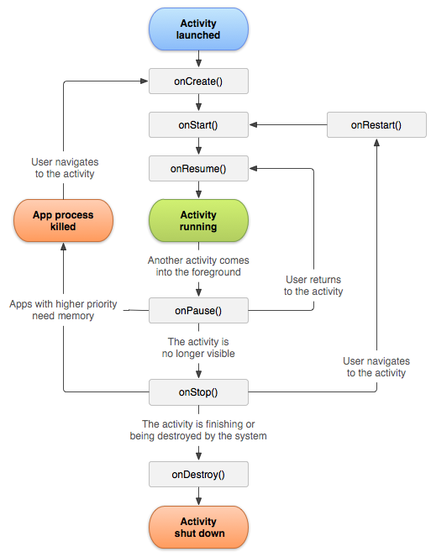

We have created many activities like for Registration and Login. We have also created separate activities for each data structure and algorithm.

**We have used**

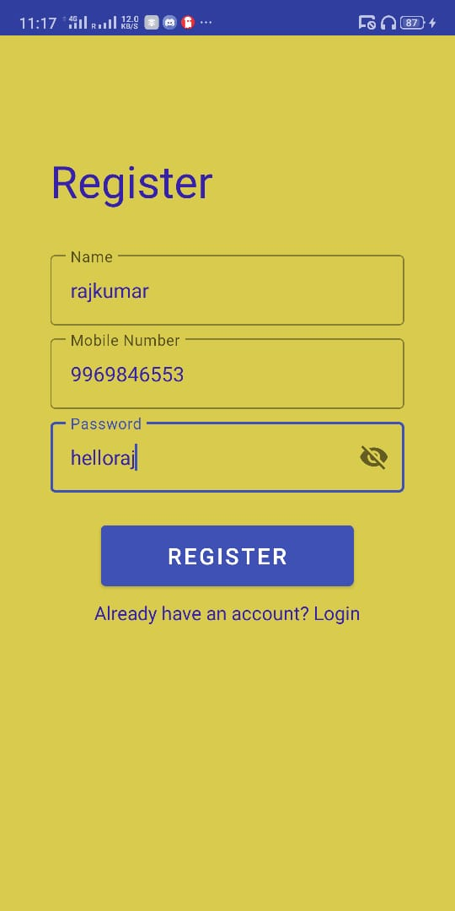 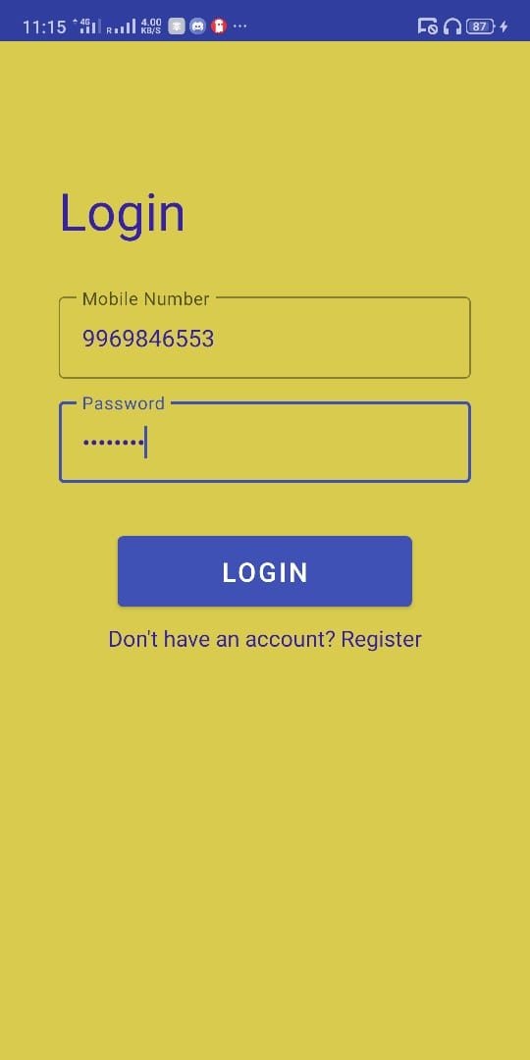

Registration Page Login Page

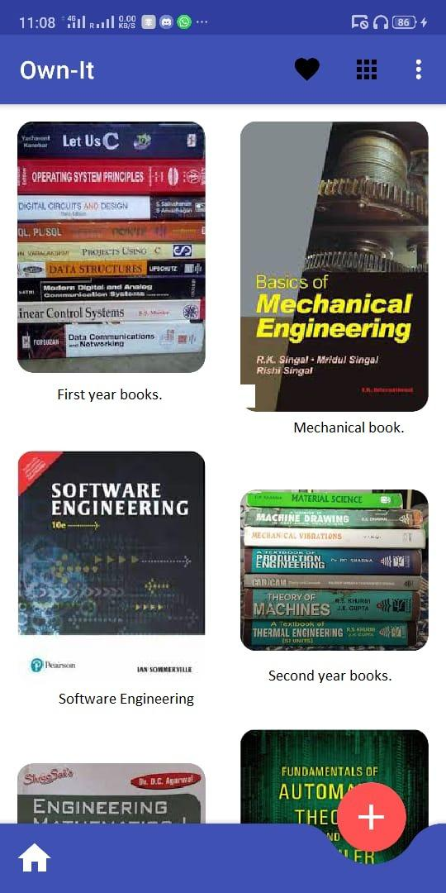 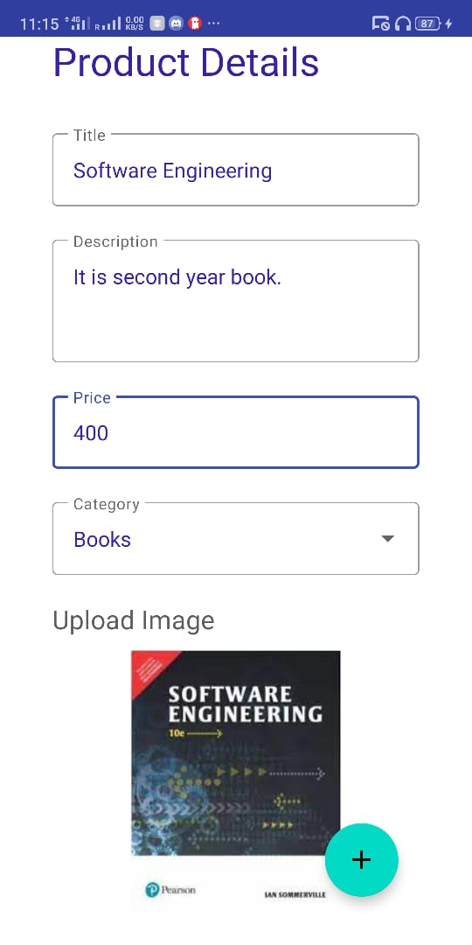

Dashboard Create Advertisement

**4.4) Database**

MongoDB is a source-available cross-platform document-oriented database program. Classified as a NoSQL database program, MongoDB uses JSON-like documents with optional schemas. MongoDB is developed by MongoDB Inc. and licensed under the Server Side Public License.

MongoDB provides high availability with replica sets.[29] A replica set consists of two or more copies of the data. Each replica-set member may act in the role of primary or secondary replica at any time. All writes and reads are done on the primary replica by default. Secondary replicas maintain a copy of the data of the primary using built-in replication. When a primary replica fails, the replica set automatically conducts an election process to determine which secondary should become the primary. Secondaries can optionally serve read operations, but that data is only eventually consistent by default.

If the replicated MongoDB deployment only has a single secondary member, a separate daemon called an arbiter must be added to the set. It has a single responsibility, which is to resolve the election of the new primary.[30] As a consequence, an idealized distributed MongoDB deployment requires at least three separate servers, even in the case of just one primary and one secondary.

**We have used Mongodb to store the user details entered at the time of registration, posts created by users. Mongodb helps the app to retrieve the data for dashboard.**

**4.5) Camera**

**Camera** is mainly used to capture picture and video. We can control the camera by using methods of camera api.

Android provides the facility to work on camera by 2 ways:

1. By Camera Intent
2. By Camera API

**We have used camera to allow users to take a picture for the advertisement. We used the Camera Intent.**

*Intent takePicture = new Intent(MediaStore.ACTION_IMAGE_CAPTURE);*

**4.6) Location API**

The location APIs available in Google Play services facilitate **adding location awareness to** your app with automated location tracking, wrong-side-of-the-street detection, geofencing, and activity recognition.

**We have used location api to take the address of the seller.**

**4.8) Multimedia**

Optional.

Intro to Multimedia. Use of Multimedia in your apps.

We have used multimedia for advertisement images

**4.9) Security features/ any other additional Android components used in app**

Features added additionally can be explained in detail here

* All the passwords stored in our application are encrypted.
* Without registration user is not allowed to enter the application.

**4.10) Generate APK**

Steps with SS to show Android APK signing process for your app

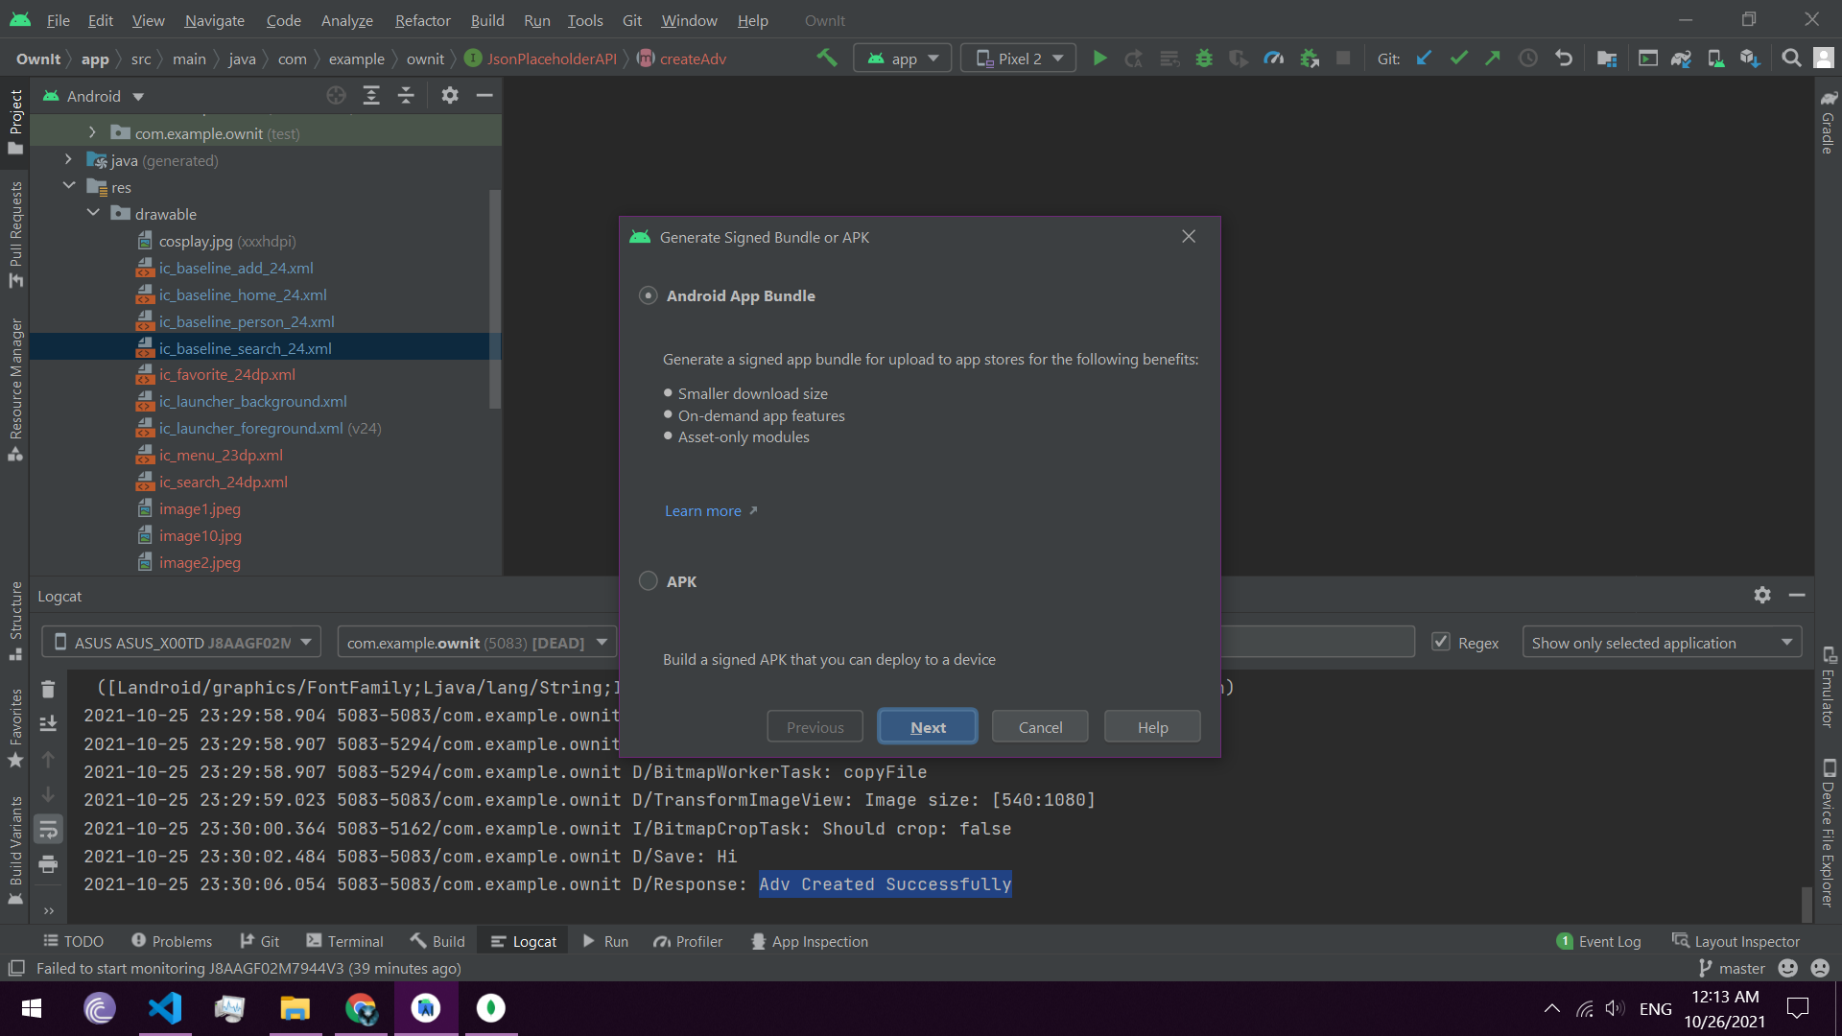

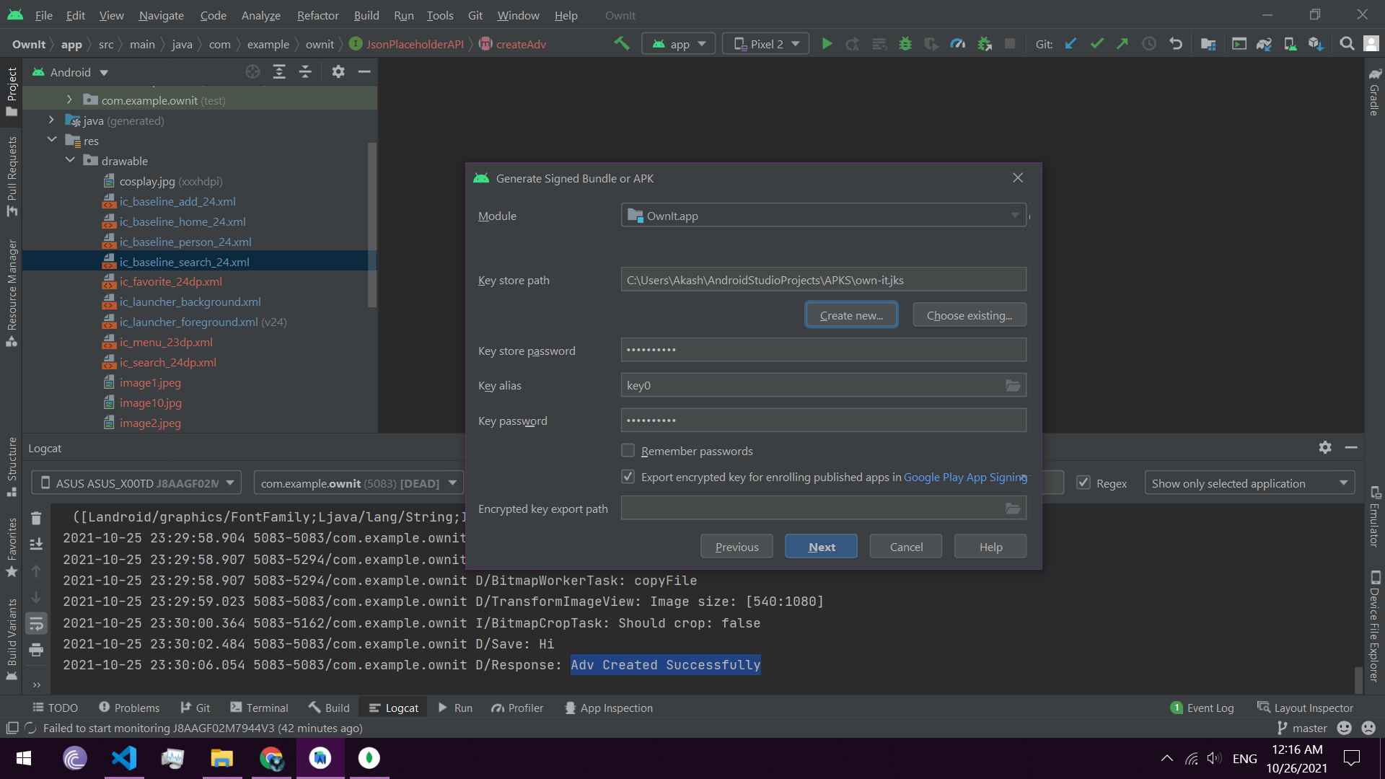

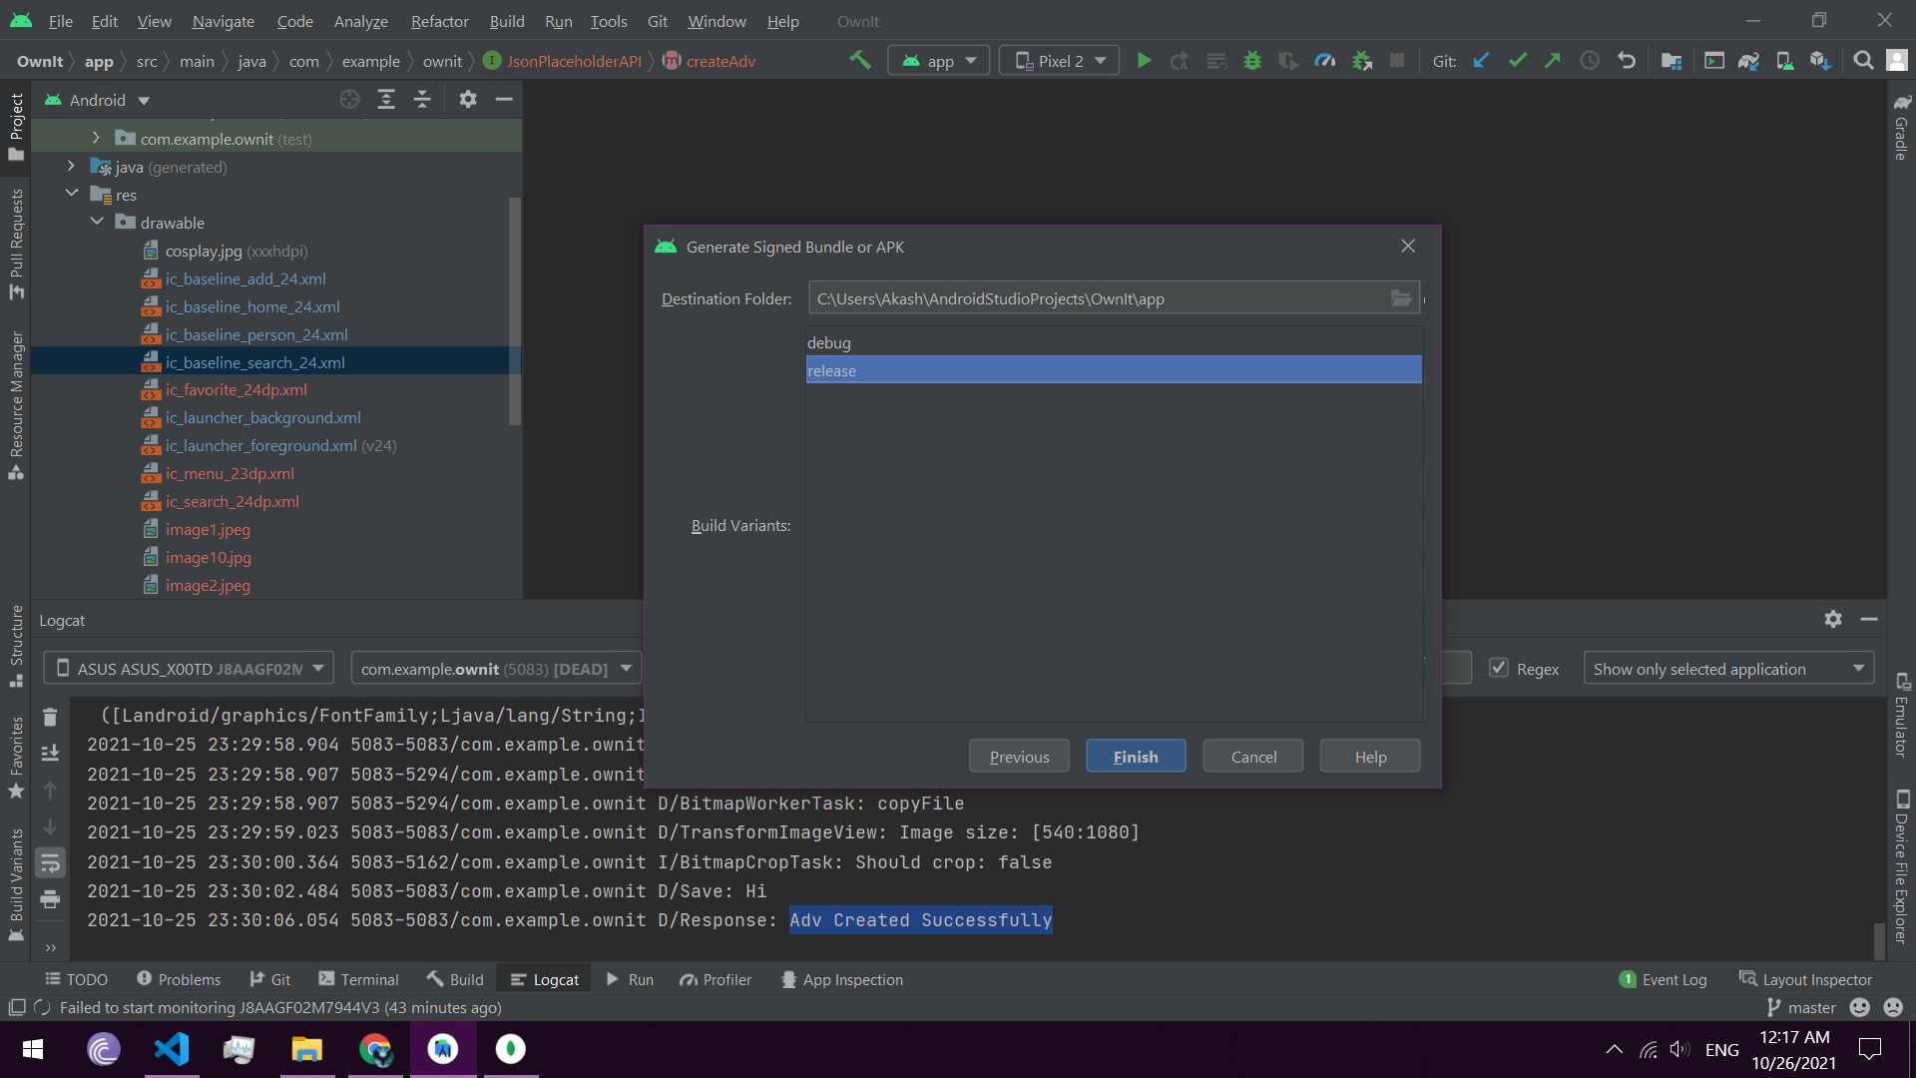

**Report on Proposed System and its Implementation**

**Block Diagram:**

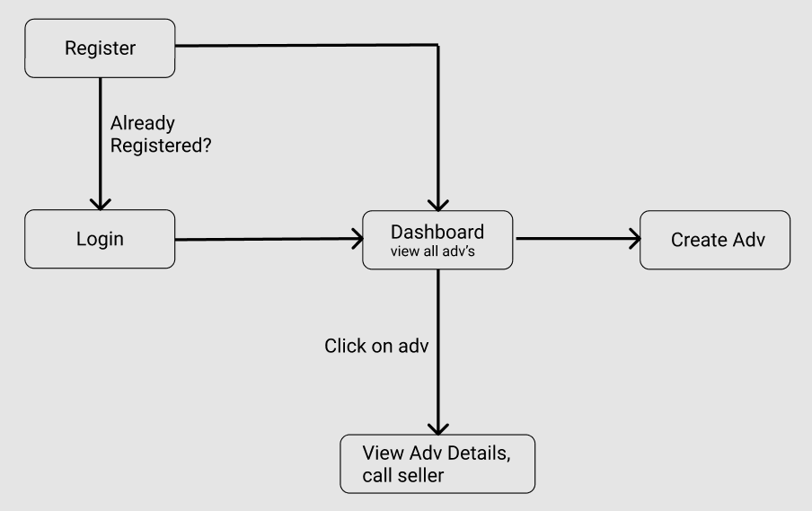

**Fig.1**

**Flowchart:**

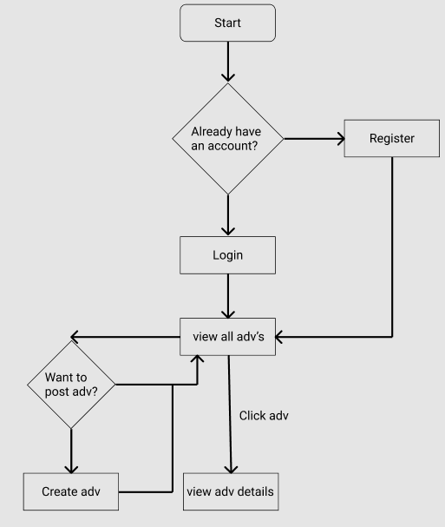

**Fig.2**

**Hardware –**

* Android Device
* GPS
* Internet
* Camera (For QR Code Scanning)

**Software / External Libraries used with description –**

* **Android Studio**

Android Studio provides a unified environment where you can build apps for Android phones, tablets, Android Wear, Android TV, and Android Auto. Structured code modules allow you to divide your project into units of functionality that you can independently build, test, and debug.

**Results and Discussions :**

**Module A:**

User Authentication

This is the First Step of using the app, every user has to authenticate himself/herself using his/her contact.

 

Registration Page Login Page

**Fig. 3**  **Fig**.**4**

**Module B:**

**Dashboard (view Advertisements)**

 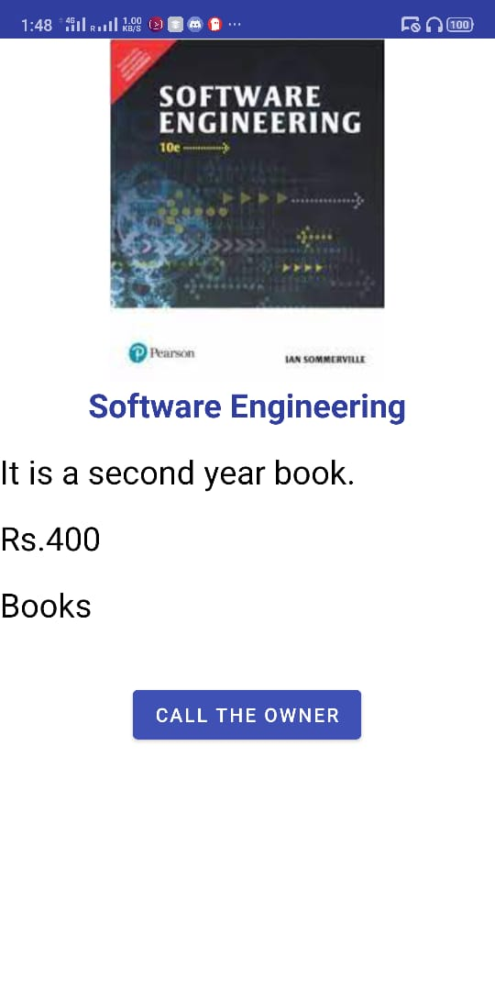

Dashboard Single Advertisement

**Fig.5 Fig.6**

**Module C:**

**Create Advertisement**



**Create Advertisement**

**Fig. 7**

**Conclusion**

Owing to time constraints, the function of this system is not perfectly realized. There is room for improvement in the future, such as system maintenance, application design patterns and the system reconstruction. And the system's design is increasingly the trend in greater scalability.

This type of system should be implemented in all the colleges, it not only recycles the miscellaneous but can also help the ones who need it, and cant afford the market price.

Future Scope:

* Chat application

**References**

1. <https://square.github.io/retrofit/>
2. <https://www.youtube.com/watch?v=RJB7us6nD-Y>
3. <https://material.io/>